|  |  |  |
| --- | --- | --- |
|  | **Rochester Institute of Technology**  **Golisano College of Computing and Information Sciences**  **School of Interactive Games and Media**  **2145 Golisano Hall – (585) 475-7680** |  |

**Data Structures & Algorithms for Games & Simulation II**

**IGME 309**

**A06 – Octree**

The purpose of this homework assignment is to show how your spatial optimization code works. There is an example executable under the _Binary folder.

Using the provided startup code (from the repository under A06) you should be able to subdivide the space into octants that will improve the FPS count. With no initial subdivision, your FPS should be low, if you have a really good computer at hand and without any spatial optimization you have a really good framerate please increment the object count.

The starter code will give you this out of the box:

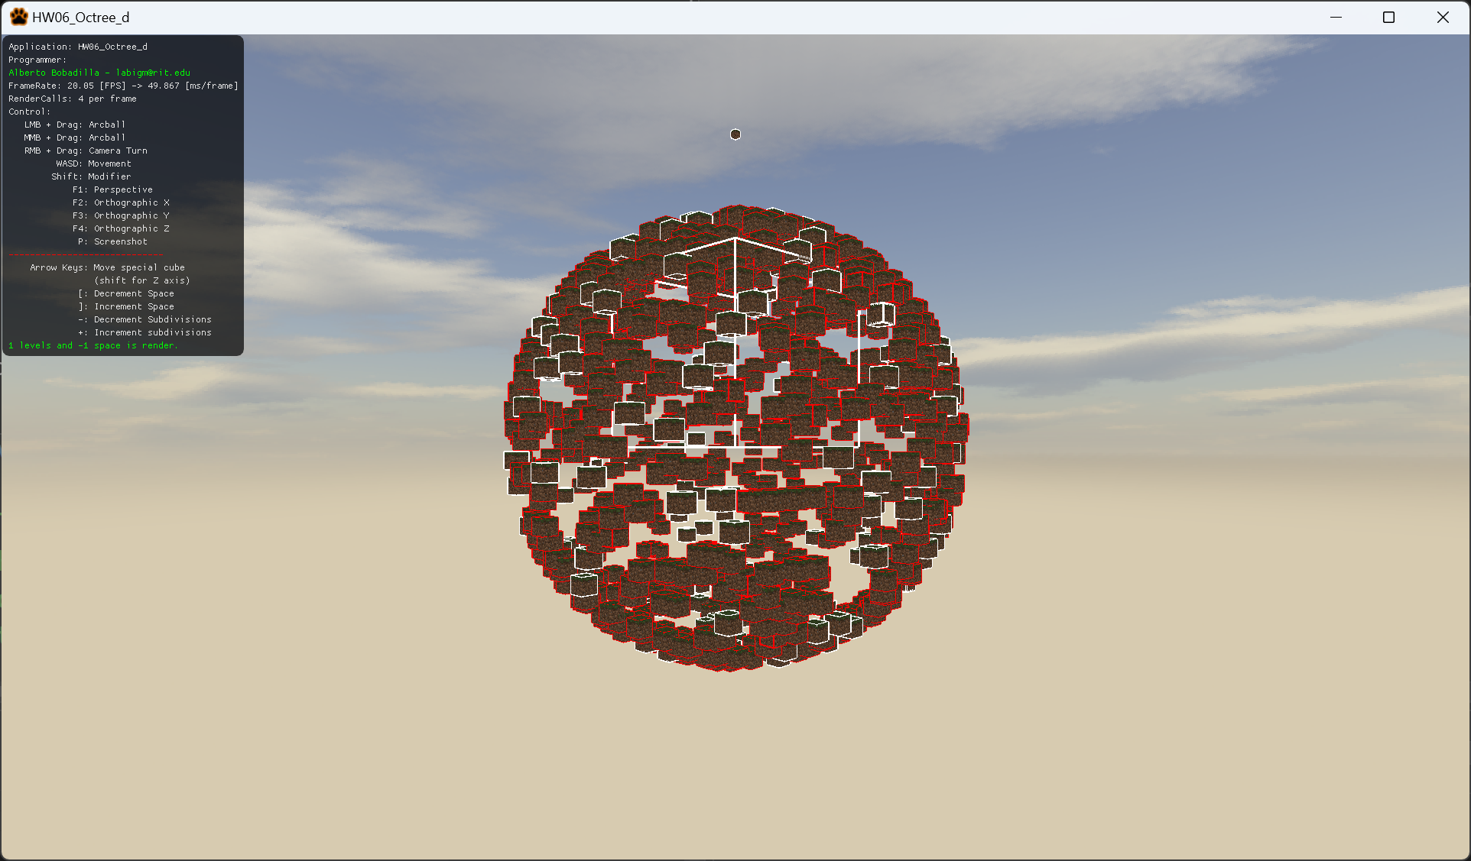

All objects need to be checked for collision and your spatial optimization data structure needs to be displayed. With the press of a button your spatial optimization should be switched to a brute force check and backwards (you should also include the framerate in display and whether your spatial optimization data structure is enabled or not).

As usual, feel free to use your own solution or base your deliverable on the provided code.

All colliding objects should display it ARBB as red and all other objects should display it in white.

Your grade will be as follows:

30% Enable / Disable Octree check (Or increment and decrement the octree subdivision level).

15% Recreate data structure on the fly. (this is tied to the first point)

55% Increment FPS *visibly* by having SO check enabled. I know this varies computer to computer, by visibly I mean that I’m flexible, but if your performance gain is less than a couple of fps then probably it means you need to improve your tree search.

Note: Your code will increment naturally if you compile in Release, your code will be graded in Debug

If you are not starting from scratch but using the provided startup you need to fully implement the following methods:

Node::Node(uint a_uMaxLevel, uint a_uIdealEntityCount)

Node::Node(vector3 a_v3Center, vector3 a_v3Size)

bool Node::IsColliding(uint a_uRBIndex)

bool Node::ContainsAtLeast(uint a_nEntities)

void Node::Subdivide(void)

void Node::AssignIDstoEntities(void)

Some of these methods are partially implemented but all are heavily commented and you could use the code from the grid as a base.

There is no extra credit for this assignment.

***Submit to the dropbox labeled: A6 – Octree***

As usual the required submission asks only for the project folder, not the whole solution, it should be no larger than 200kb if you are using the starter code (and you remove this document from that folder). If you are using your own framework/engine please submit the whole solution. Push your solution to your repository with the comment “**A06 Deliverable**” then zip the project (or solution) and upload it to the dropbox, in the comments section you need to specify the address of your repository.